Copy the file "MPFAN - C.pst" to the "C:\Users\Public\Documents\Shared Mastercam 2021\mill\Posts" folder;

make a new project,then operate according to the following picture
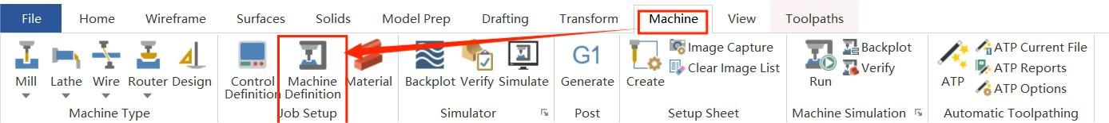

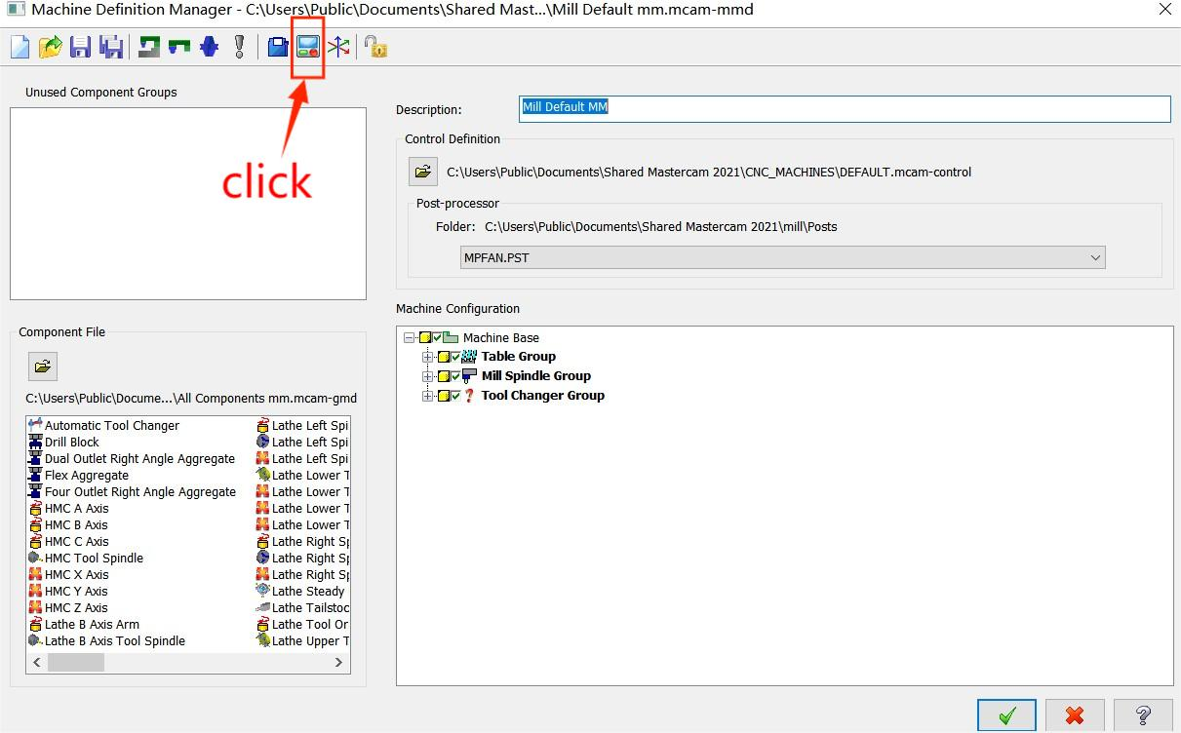
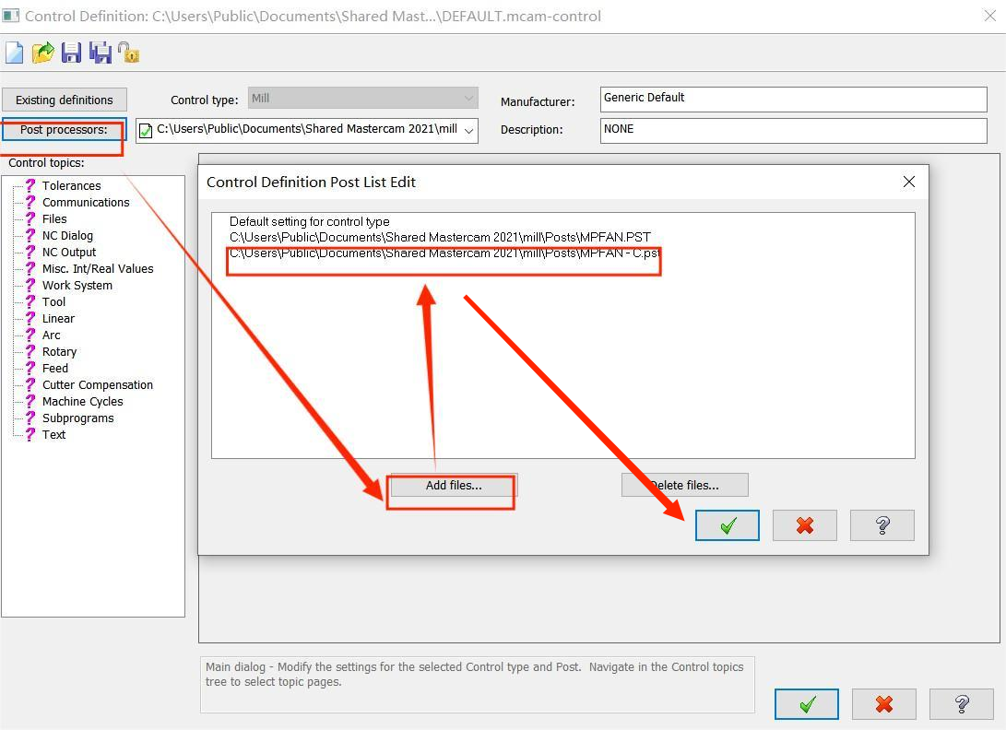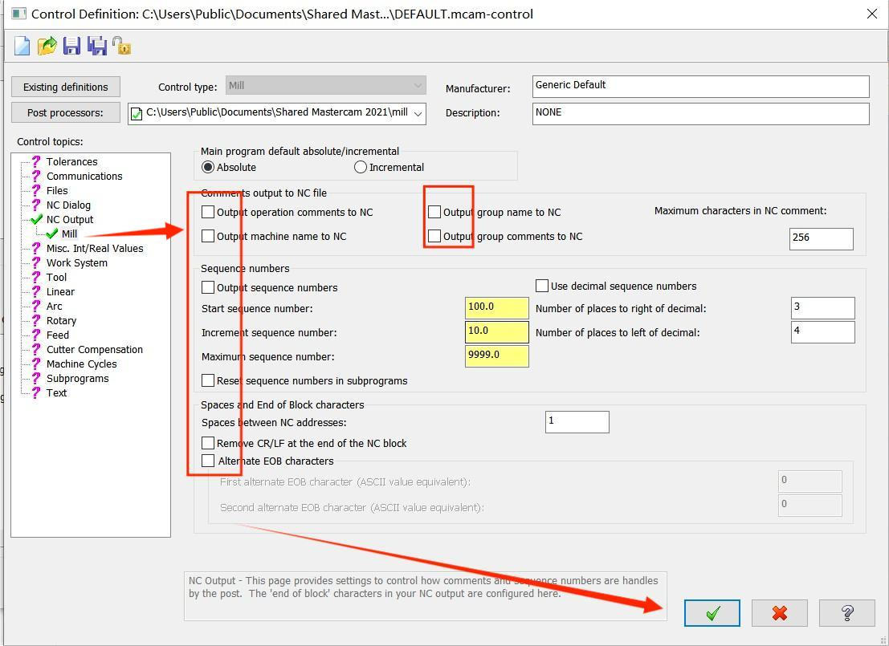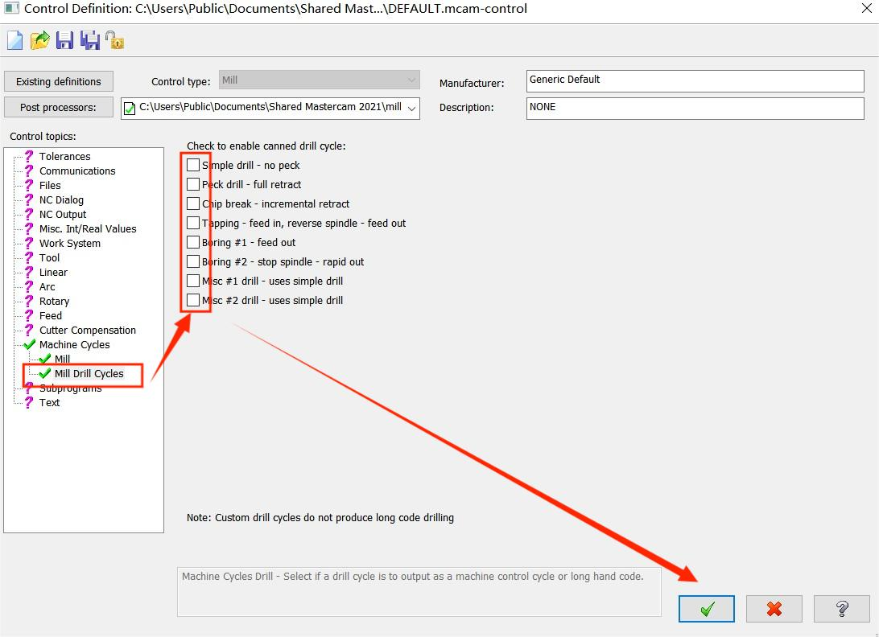
Then click all “yes”;
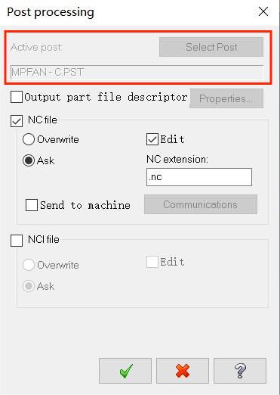
Make sure the active post is “MPFAN-C.PST”;

If the active post is not “MPFAN-C.PST”
